Register No: 192411197
Student: D. VYSHALI
Assigned Question:
Q22. Debugging Bubble Sort Code (Missing Early Termination Optimization)
The following Bubble Sort code eventually produces the correct output, but it performs unnecessary passes even when the array becomes sorted early. Carefully analyze the existing implementation and identify the inefficiency in loop execution. Apply debugging and optimization techniques to introduce a flag-based termination mechanism. Explain how this optimization improves the practical performance of the algorithm. Analyze the corrected version in best, average, and worst cases. Rewrite the final optimized code with proper comments and readable structure.
Original (Buggy / Unoptimized) Code:
def bubble_sort(arr):
n = len(arr)
for i in range(n):
for j in range(0, n-i-1):
if arr[j] > arr[j+1]:
arr[j], arr[j+1] = arr[j+1], arr[j]
return arr
Output:
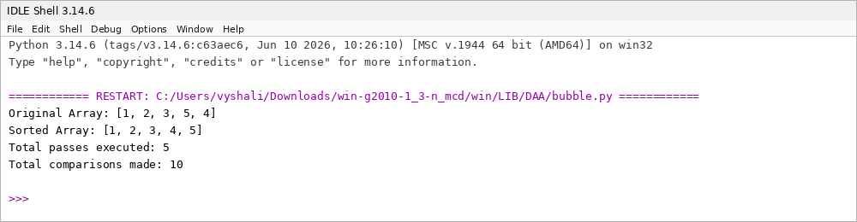
Figure 1: Output of the original (unoptimized) Bubble Sort implementation
Inefficiency Identified:
- For the test array [1, 2, 3, 5, 4], the array is already fully sorted after Pass 2, yet the outer loop has no way of knowing this.
- The code always runs exactly n passes (5 passes for n = 5) and performs n(n−1)/2 comparisons (10 comparisons), regardless of whether the array became sorted early.
- Passes 3, 4, and 5 perform comparisons but make zero swaps — this is wasted computation on an already-sorted array.
Correction:
Introduce a boolean swapped flag at the start of every outer-loop pass. Set it to True whenever a swap occurs in the inner loop. If a full pass completes with the flag still False, the array is already sorted and the outer loop can terminate immediately using break.
Debug / Optimize the Program:
Replace
for i in range(n):
for j in range(0, n-i-1):
if arr[j] > arr[j+1]:
arr[j], arr[j+1] = arr[j+1], arr[j]
return arr
with
for i in range(n):
swapped = False
for j in range(0, n-i-1):
if arr[j] > arr[j+1]:
arr[j], arr[j+1] = arr[j+1], arr[j]
swapped = True
if not swapped:
break
return arr
Optimized Output:
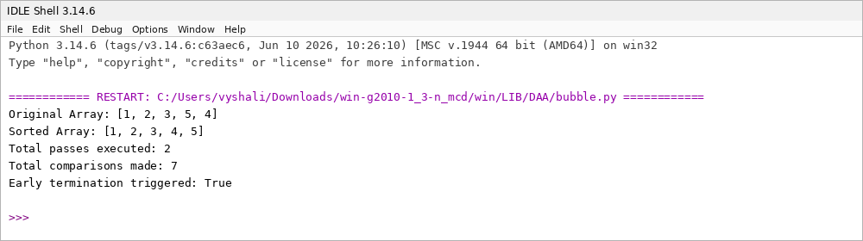
Figure 2: Output of the optimized Bubble Sort implementation with early termination
Final Optimized Code (Clean Version with Comments):
def bubble_sort(arr):
"""
Sorts a list in ascending order using an optimized
Bubble Sort with flag-based early termination.
"""
n = len(arr)

for i in range(n):
swapped = False # tracks whether any swap occurred this pass

# Last i elements are already in place
for j in range(0, n - i - 1):
if arr[j] > arr[j + 1]:
arr[j], arr[j + 1] = arr[j + 1], arr[j]
swapped = True

# If no elements were swapped, the array is already sorted
if not swapped:
break

return arr
Explanation of Improvement:
Bubble Sort's outer loop is meant to guarantee that, after i passes, the largest i elements are correctly placed at the end of the array. Once a full pass makes no swaps, every remaining element is already in its correct position, so continuing to iterate provides no benefit. The unoptimized version ignores this signal entirely and always executes all n passes.
Adding the swapped flag lets the algorithm detect this state after each pass and exit immediately via break. For the demonstration array [1, 2, 3, 5, 4], the optimized version terminates after just 2 passes and 7 comparisons instead of 5 passes and 10 comparisons — a meaningful reduction for this small example, and a much larger one on longer, nearly-sorted arrays, which are common in real-world data such as incrementally updated logs or partially maintained records.
Time Complexity Analysis (Optimized Version):
Case | Complexity | Explanation
Best Case | O(n) | Array is already sorted; a single pass makes no swaps and the loop terminates immediately.
Average Case | O(n²) | Elements are in random order; multiple passes with swaps are typically required.
Worst Case | O(n²) | Array is sorted in reverse order; every pass performs the maximum number of swaps and no early exit is possible.
Space Complexity | O(1) | Sorting is performed in place using only a constant number of extra variables (i, j, swapped).

Optimization Summary:
- Added a swapped flag for early termination once the array becomes sorted.
- Added comments explaining the purpose of each block for readability.
- Maintained consistent variable naming (arr, i, j, n, swapped).
- Preserved the original in-place, stable sorting behaviour while reducing unnecessary passes on best-case and nearly-sorted input.

